1. A 4-stage pipeline has the stage delays as 150, 120, 160 and 140 nanoseconds respectively. Registers that are used between the stages have a delay of 5 nanoseconds each. Assuming constant clocking rate, the total time taken to process 1000 data items on this pipeline will be



1. Consider an instruction pipeline with four stages (S1, S2, S3 and S4) each with combinational circuit only. The pipeline registers are required between each stage and at the end of the last stage. Delays for the stages and for the pipeline registers are as given in the figure:



[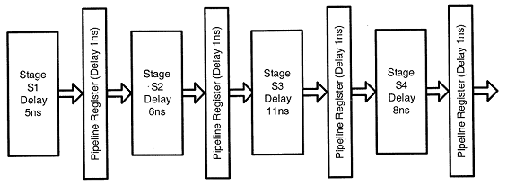](https://media.geeksforgeeks.org/wp-content/cdn-uploads/gq/2013/12/GATECS2011Q41.png)



What is the approximate speed up of the pipeline in steady state under ideal conditions when compared to the corresponding non-pipeline implementation?



1. Consider the following procedures. Assume that the pipeline registers have zero latency.



P1 : 4 stage pipeline with stage latencies 1 ns, 2 ns, 2 ns, 1 ns



P2 : 4 stage pipeline with stage latencies 1 ns, 1.5 ns, 1.5 ns, 1.5 ns



P3 : 5 stage pipeline with stage latencies 0.5 ns, 1 ns, 1 ns, 0.6 ns, 1 ns



P4 : 5 stage pipeline with stage latencies 0.5 ns, 0.5 ns, 1 ns, 1 ns, 1.1 ns

Which procedure has the highest peak clock frequency?



1. Consider a non-pipelined processor with a clock rate of 2.5 gigahertz and average cycles per instruction of 4. The same processor is upgraded to a pipelined processor with five stages but due to the internal pipeline delay, the clock speed is reduced to 2 gigahertz. Assume there are no stalls in the pipeline. The speed up achieved in this pipelined processor is-



Q5. A CPU has a five-stage pipeline and runs at 1 GHz frequency. Instruction fetch happens in the first stage of the pipeline. A conditional branch instructioncomputes the target address and evaluates the condition in the third stage of the pipeline. The processor stops fetching new instructions following a conditional branch until the branch outcome is known. A program executes 109 instructions out of which 20% are conditional branches. If each instruction takes one cycle to complete on average, the total execution time of the program is:



Q6. An instruction pipeline has five stages where each stage take 2 nanoseconds and all instruction use all five stages. Branch instructions are not overlapped. i.e., the instruction after the branch is not fetched till the branch instruction is completed. Under ideal conditions,

1. Calculate the average instruction execution time assuming that 20% of all instructions executed are branch instruction. Ignore the fact that some branch instructions may be conditional.



1. If a branch instruction is a conditional branch instruction, the branch need not be taken. If the branch is not taken, the following instructions can be overlapped. When 80% of all branch instructions are conditional branch instructions, and 50% of the conditional branch instructions are such that the branch is taken, calculate the average instruction execution time.

